**Army Public School & College JPJ CANTT**

**Preparatory Test Series( PTS I ) 2023**

**Subject: Computer Science - I Class: XI Section: ________**

**Name: ______________ Roll No : ___________ Date: ________**

**Total Marks: 50 Obt. Marks: ____**

**Section - A**

**Q.No.1. Choose the correct option: (1x10=10)**

|  |  |  |  |
| --- | --- | --- | --- |
| **i.** It is the raw material given as input to the computer for processing: | | | |
| A) Data | B) Information | C) Database | D) DBMS |
| **ii.** It is a collection of related files | | | |
| A) DBMS | B) Database | C) Data Modelling | D) Data Analysis |
| **iii.** Which theoretical foundation of a data base determines that how data is stored, organized, and manipulated? | | | |
| A) Database Model | B) Database Structure | C) Database Design | D) Database Architecture |
| **iv.** The relationship between entities AUTHOR and BOOK is: | | | |
| A) Unary | B) Binary | C) Ternary | D) Recursive |
| **v.** Identify the cardinality of the following relationship: One COLLEGE can have many DEPARTMENTs, One DEPARTMENT belongs to one COLLEGE. | | | |
| A) One-to-One | B) One-to-Many | C) Many-to-Many | D) Many-to-One |
| **vi.** It defines a way of structuring data | | | |
| A) Database | B) Data Model | C) Data Analysis | D) Data Modification |
| **vii.** SQL stands for | | | |
| A) Structured Query Language | B) Structured Query List | C) Simple Query Language | D) None of these |
| **viii.** In relational database, rows are also known as: | | | |
| A) Field | B) Relation | C) Attribute | D) Tuples |
| **ix.** The person responsible for supervising the database is known as: | | | |
| A) DBMS | B) Database Manager | C) DBA | D) All of these |
| **x.** If data is not updated in any file, it causes | | | |
| A) Data Redundancy | B) Data Inconsistency | C) Data Overflow | D) Invalid Data |

**Section - B**

**Q.2. Write short answers. All questions carry equal marks. (3*10=30)**

1. What is the importance of information extracted from processed data?
2. What were the drawbacks of File Management System?
3. State any three Advantages to DBMS with explanation.
4. Give some examples of DBMS software.
5. Write down any three responsibilities of DBA.
6. What is meant by database model?
7. How many types of SQL languages for relational databases?
8. Which steps are involved in planning a database?
9. What is the importance of ER Diagram?
10. Define normalization.

**Section –C**

**Q.3. Briefly explain the following question. (10)**

1. Understand the ER Diagram and write the answers of the following questions:

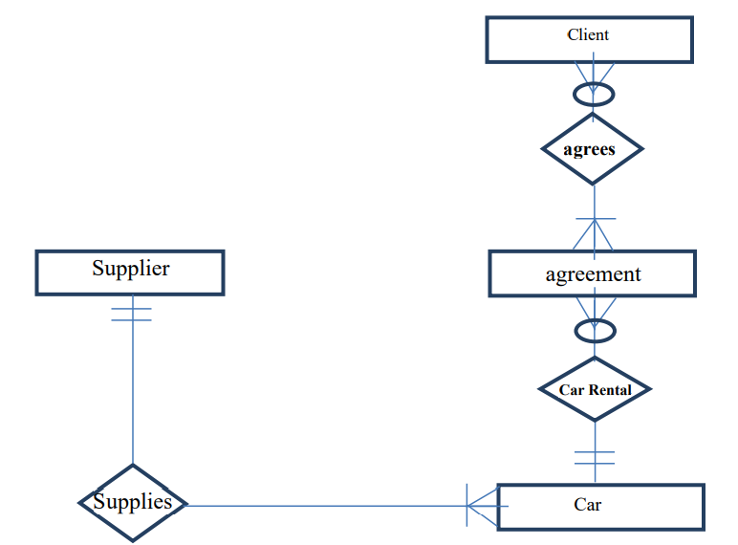

1. List one example of one-to-many relationship.
2. Mention Entities used in ER diagram.
3. How many minimum cars supplier must supplies?